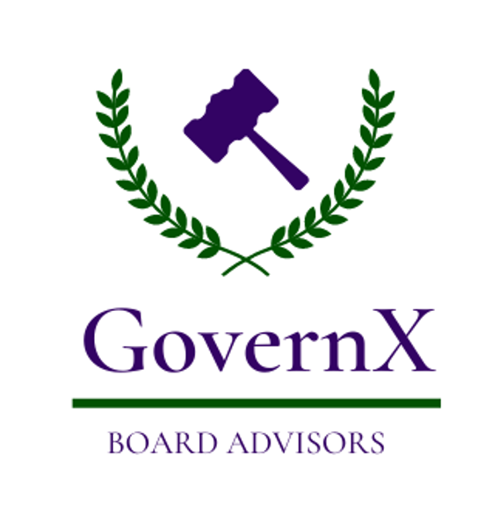

How to get on the Board of Directors
of a for-profit company?
By Dennis Cagan
This is a question that I frequently get asked. In April 2012, Directors & Boards magazine published an article I authored titled, Finding directors for the smaller and early-stage company. After it came out, I expected to hear from some companies with some questions or even a consulting job. Not one company called. However, I did get almost 100 emails and calls from individuals who wanted to know how they could get on such a board.
Many years ago, when asked this question I would simply reply, “It’s easy. You just have to be on a board.” That’s the rub. How do you get on your first for-profit board? Earlier I had such a call from a gentleman in his 50’s who is very qualified in his industry and has been on the boards of numerous non-profits and trade associations, but never a company. This call prompted me to think that it would be worthwhile to jot down some tips. Getting on your first board is not Rocket Science. There is no Secret Sauce. It just takes legwork and persistence.
Here are some of my time-tested tips. In an effort to lighten this up, I have coined the process LABOR.
- Learn: Learn all you can about boards. All types of boards but primarily company fiduciary and advisory ones. Spend some time delving into governance in general. The more you know about the issues, processes, and regulations, the more value you bring to the table. [Commercial: Buy my book, The Board of Directors of a Private Enterprise - bit.ly/CaganBoardBook, and consider joining organizations near you such as the University of Texas, Dallas, Naveen Jindal School of Management, Institute for Excellence in Corporate Governance - https://jindal.utdallas.edu/centers-of-excellence/iecg/.

- Assess: Assess your unique combination of skills and experience. What is it about you, what you have done, your skills, and the places your career has taken you that would be of value to a company desiring solid advice and voluntary oversight? I have a saying that, “being qualified to be on a particular board does not make one suitable.” There are any number of folks that have held job titles similar to you, in companies similar to your career, live in the same geography as you do, and have likely learned similar lessons as you have. What is unique about you, and why would that be of value to a company – and fairly specifically, what kind of company in what business?

- Board Bio: Everyone already has a standard bio, and/or a CV, or a summary of their achievements. It may be out-of-date, but you have one. Well, this is NOT a board bio. A board bio is much different. While a typical bio and resume articulate facts about you and what you have done, all that is just the data that backs up your board bio. The board bio centers on your value to a particular company as a board director. What things you specifically bring to a board. What boxes do you check? Your CV notes the positions that gave you the experience to deliver that value, but not the value itself. It is not a report of your jobs, but rather an analysis of your unique combination of assets, targeted to the particular set of needs that a board might be searching for. I often tell people that the board bio is the question that you are the answer to. Q: Who has the following skills and experience that we need? A: You!

- Others: If no one knows you are interested in sitting on a board, it dramatically reduces the chances of being asked. Talk to others - key folks in your network - about your 'board' interests. Identify those that might be in a position to hear about openings and even recommend candidates. Unless you are very well known it may take some time before word gets to someone that actually hears about an opportunity. Of course, this is a very old concept known as networking. Access organizations, individuals (particularly existing board directors), advisors (attorneys and accountants), and companies. Participate and engage. It is often about being in the right place at the right time. Find the gatherings, organizations and events attended by company owners, senior executives, board members, and entrepreneurs. Come out of your shell. It does not have to be a blatant ask, you can just mention that you are interested in director opportunities.

- Roadmap: This is not science, it’s art. You cannot really know what route or actions will ultimately lead to your joining a board, but you can certainly speculate. Map the most likely route to your objective, e.g. Non-profit, small private (start-up, family business), smaller public, etc. Identify the types of organizations most likely to be in need of your contribution. Think about the different categories of private companies and non-profits. Depending on your seniority it could be more like climbing a ladder than hopping out of a helicopter on top of the 'board' heap. Chart some potential courses to the goal and note the actions and contacts most likely to end your search successfully.

There it is, LABOR. One last important note. If you are doing all this to earn money, don’t bother. Only exceptionally high-profile individuals and those with extraordinarily special qualifications typically land a big board seat out of the gate. Everyone else works their way up, paying their dues with non-paying, equity-only, or low-paying board positions to start.

One additional tip. If you are currently the owner or CEO of a company, do you have a board? If so, are you on it? Is it just you, or perhaps you and your spouse or business partner? If so, your 'first real board' is just one simple step away. Formalize your own company board and add one or two independent directors and you are now on a real board (for more on this, read my book or give me a shout.)

Over the last 52 years I have enjoyed gaining an unparalleled education in governance from the amazing men and women who I have shared 67 corporate boards with. I wish you all the best in having a similarly wonderful experience. Many colleagues have heard my personal wish, “When I pass away, I’d like it to be in a board meeting, while I’m wearing my trademark Hawaiian shirt and Sperry deck shoes.” God bless.

Dennis Cagan is a Managing Director of GovernX LLC. He is a noted high-technology entrepreneur, executive, and board director. He has founded or co-founded over a dozen different companies, taken some public, been a CEO of both public and private companies, a venture capitalist, a private investor, a consultant, and a long-time professional board member – over 67 corporate fiduciary boards. His book, The Board of Directors of a Private Enterprise, is considered one of the definitive works on the subject. Mr. Cagan is a respected CEO and Chairman. He founded his first software firm in 1968. In 1976 he founded his fifth company. In 1980 it was ranked #32 on the first Inc. 100. His first public board seat was when he took the company public in 1981. In 1979 he was the Keynote Speaker at the first COMDEX Show in Las Vegas. In 2011 he was inducted into the IT Hall of Fame - Channel Wing, administered by CompTIA. In 2013 he was honored by NACD and the Dallas Business Journal as one of 12 Outstanding Directors in North Texas. Mr. Cagan can be contacted at dennis@caganco.com.

©2021 by GovernX LLC. All rights reserved. No portion of this document may be reproduced in any form whatsoever without prior written permission from the publisher.

