A Board of Directors
Qualification Matrix
By Dennis Cagan
The vetting of potential candidates for any board of directors is the most important initial step in seating a new member – whether you are replacing the position, adding to the number of directors, or forming you first board. There are a wide variety of techniques used to organize this process ranging from ad hoc random discussions to highly-organized detailed specifications and comparisons. In over 50 years of helping to create and expand boards we have found that the use of a simple Qualification Matrix is among the most effective and easiest to use method.
PURPOSE
This type of matrix allows the comparison of potential directors or advisors across areas of expertise and experience that have been identified to be critical to the future success of the company. We believe that Independent directors can then be selected so as to achieve the broadest and deepest mix of relevant qualifications by focusing on four primary areas: job skills, experience, personality and contacts (together termed ‘characteristics’). The combination of these characteristics that best fit your organization’s needs comprises the total value of a potential director.
To achieve best-of-class governance it is normally recommended that a company add independent directors so as to outnumber inside or affiliated directors by a minimum of one. This is generally required of publicly traded companies and is widely considered best-practice for private for-profit and non-profit entities. It is further recommended that the board’s chairmanship be preferably held by an ‘outside’ independent director or if necessary, an inside director other than the CEO. If an inside director is chosen, best practice would dictate that an independent director be designated as presiding or lead director. This position then has the charter to lead the board whenever the ‘insider’ chairperson is either absent or conflicted out.

IDENTIFYING NEED(S)

The process of developing a matrix must start with an in depth discussion and consensus among both the board and senior management to define the skill sets, experience by position, industry and geography; desirable contacts with individuals or organizations, and the ideal personality that would represent the best fit and be of maximum value to the company.

This discussion should be deliberate and include the entire board and senior executives, however the Governance/Nomination committee of the board will often develop an initial draft. The real secret sauce here is to first identify a comprehensive list of characteristics that are collectively determined to represent the most critical ones for the company to possess to ensure its achievement of established short-term and long-term goals.

According to a report of the National Association of Corporate Directors (NACD) Blue Ribbon Commission on The Governance Committee, some of the recommended criteria include:
- Personal Traits/Characteristics – demonstrated ethical standards, integrity, and accountability.
- General Business Traits – track record of achievements.
- Independence Standards – meeting accepted requirements.
- Senior Leadership Experience – appropriate management disciplines and levels of responsibility.
- Other specific areas of experience or qualifications – e.g., business development, M/A, financial, previous board experience, diversity, industry (domain) experience, operations/manufacturing, geographic (global), information technology, brand marketing, governmental, regulatory, etc.

Once a complete list of these determinations are placed in a matrix format, the ‘boxes’ that represent those attributes already possessed by the combination of current senior management and the existing board of directors may be ‘checked off.’ The open boxes then represent those attributes that this exercise deems are missing or in need of being strengthened. These may then be ranked by priority. More specifically desired demographical attributes regarding gender, race, ethnicity, etc. may then also be added or overlayed.

Since this article is about qualifying and vetting director candidates, and not about finding them, we will defer that topic for another time. Suffice it to say that the next step is surfacing potential qualified individuals. If your needs are narrow you may only identify only a small number of people. If you needs are broader you may need to compile a much bigger list. After initially talking with the candidates you have identified, consider their qualifications and re-examine the best potential mix to gain maximum board diversity across all the critical areas. If necessary, refine your matrix based on any new knowledge or awareness.

POPULATING THE MATRIX

The next step is to enter each candidate in your matrix, matching the list of potential directors to the qualifications. As the process of narrowing down continues. Match up all the players, rank them by preference, categorize their skills, compare qualifications against your matrix, and sort and shuffle.

At the appropriate time, I strongly advise a practice here which unfortunately is not as widely practiced by boards as one might expect. It is my belief from experience that all the current board members should talk directly with at least the final two or three candidates. This does not seem to be the norm, but as you can imagine it goes a long way to developing the confidence, trust, and respect of each board member for the other. When the final choice(s) is/are made, the new director(s) will have a much smoother onboarding and entry experience and will be productive all the sooner. There is no better way to go about assessing the cultural and personality fit than a personal interview. There is a temptation to do a group interview, with two or more directors together, however from my experience, this does not provide the optimal benefit in determining a person’s ultimate fit.

One thing that is hopefully ‘baked’ into the definition of characteristics in the matrix is the stage of development the organization is in. This can sometimes equate to age, but not necessarily.

- Is the company a start-up, with no revenue?
- Is it operating, generating revenue, and approaching cash flow neutral – regardless of age?
- Is it cash flow positive?

In the last example age does enter into the equation. A young company that is profitable is different than an old one that may have struggled previously and is now profitable, or one that has been profitable for a longer period of time. Is the company likely to experience fast or slow growth going forward? Is the company being positioned for long-term ownership, or being groomed for sale or an IPO (initial public offering)?

Example: A Large Non-Profit (candidates shown are not actual)
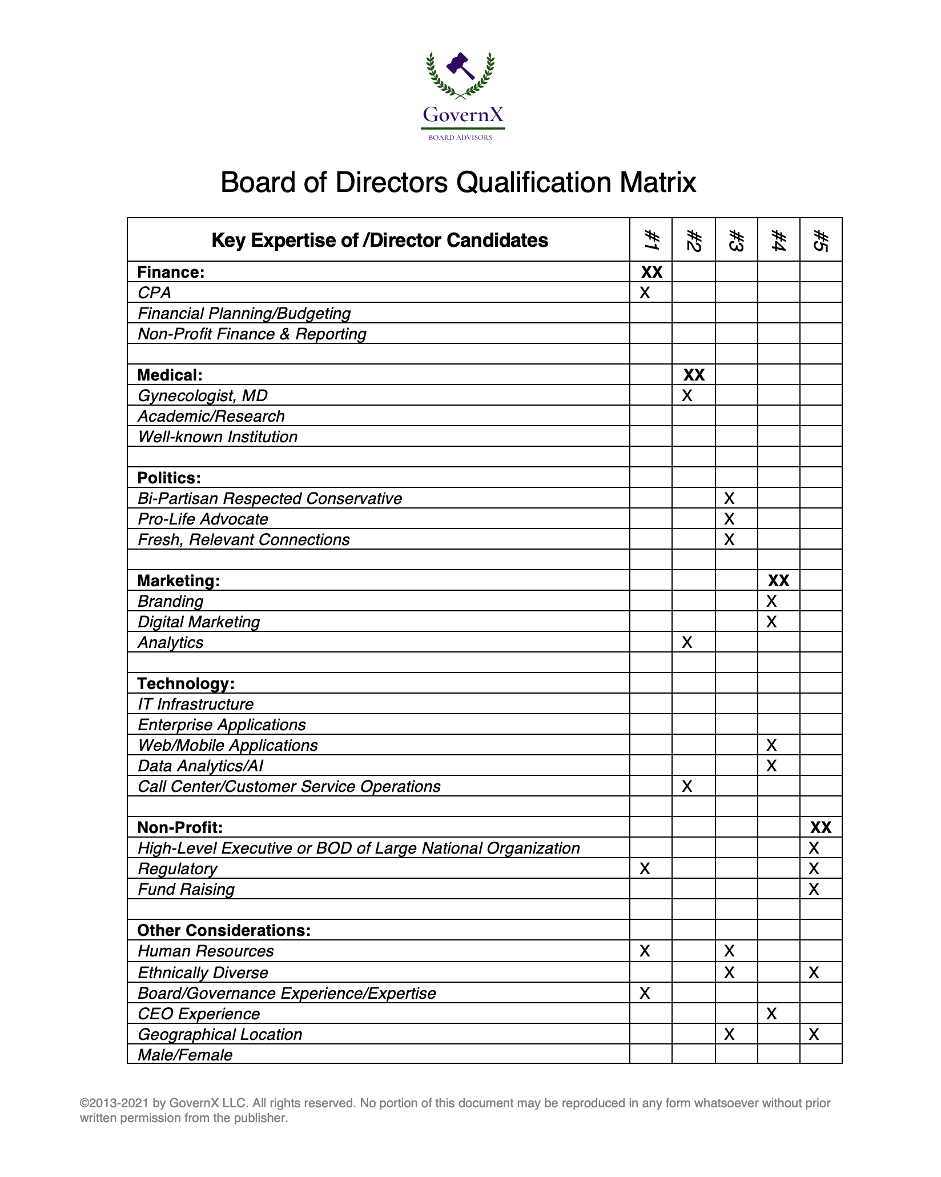
The matrix above is a very simple example that compares five potential independent directors across twenty-six categories expertise/diversity that have been identified to be critical to the future success of one particular firm. The directors listed are being proposed to fill multiple vacant seats. This matrix does not yet factor in any cultural/personality fit.

CULTURE AND PERSONALITY
In the mix of overall qualifications there is what we have been calling culture and personality. The following is a relevant chapter from my book, The Board of Directors of a Private Enterprise. It addresses the board qualification matrix and the most important director qualities that are seldom included in a board matrix.

Book Chapter: The Most Needed, yet Least Named Qualities for a Great Board Member

There are some qualities for great directors that are seldom specified. This is a personal top-five list of the most needed — yet least identified — qualities for an outstanding board director.

It is the norm for boards to compile a matrix of the key mix of skills and qualifications needed in directors to best guide the company going forward. A matrix highlights those attributes that are already represented by current directors and those that are desirable in prospective board candidates. Typically, the named categories include job skills such as CEO or financial expertise, and specific industry domain experience. These will often be overlaid with some additional unique skills and diversity goals. Sometimes a matrix will even contain broad character traits such as ‘cultural compatibility’ or ‘leadership.’ However, there are a number of traits that can be critical to a board's success but are not often listed in any matrix.
What is in This Chapter?
There are many different qualifications that boards look for when filling out their director’s matrix. Some have to do with demographics, gender, and extend to include management skills, job specialties and industry/domain expertise. This chapter will explore five of the most important characteristics that are rarely found on the matrix.
A Simple yet Effective Tool
Whether it is formally written, which is advisable, or just a verbal discussion, a matrix of desirable board director skills, experience, and other qualifications is a simple yet effective tool in identifying which boxes you already have checked and which are best targeted in a new director.
I have participated in several board symposiums, which have all arrived at the same conclusion — that many a company’s greatest failures can be traced to a dysfunctional board. These discussions have also consistently come to the conclusion that a frequent cause of board dysfunction is personality conflicts between directors. Today’s complex fast moving global business environment requires a high-performance board in order to maximize the success of any enterprise. Yet in spite of the direct link between performance and the personal communications styles and personality traits of board members, I have never seen any of these personal attributes specifically identified in a qualification matrix.
Having had the privilege of sitting on many corporate boards over the last four-plus decades, I have observed and learned from over 250 fellow directors. Along the way I have developed my own top five list of the most important qualifications for an outstanding board director. A board can function well in executing its fiduciary responsibilities even if it is missing some specific skills or experience; however, it can be completely disrupted at a key point by just one rogue director having one heavy-handed character trait, especially if no one else on the board possesses the personality or authority to rein him or her in.
Examples might be:
- Someone who talks too much, repeating what was already stated numerous times (hijacks or filibusters the discussion), or
- One who daydreams or falls asleep (disrespectful and not adding value), or
- Is overly argumentative (polarizes members and fosters dissension).

Unless another member, preferably the chairman or presiding/lead independent director, has a personality that can appropriately counter it, that one negative director can potentially sidetrack a critical discussion, negatively impacting the business.
My top-five most desirable character traits. Come up with your own, and formally or informally add it into your board’s evaluation and nominating processes.
Courage: The Only No. 1
There may be many opinions on ranking the importance of various character traits that could contribute to a board's performance and ability to work together to provide a truer execution of its fiduciary duties. Weighting might even vary depending on the composition of any given board and the current circumstances of the firm. However, I have two important observations: only negative situations expose the nitty gritty soul of a board, and in those instances no characteristic for any director will prove more vital than courage. All others pale in comparison to the courage of a single director who is willing to voice the unstated truth of a situation, the unpopular alternative, the feared conclusion, or the out-of-the-box creative idea that could right the ship. Others may sense that action is necessary, but typically most will not muster the selfless moral strength to risk ridicule, or even rejection, to boldly articulate the unpopular deed.
Leadership and courage are not always present together, although they can be. Does the CEO have to be terminated? Does a business unit have to be closed? Does the company need to accept or reject a financing or acquisition offer? Should the firm publicly admit or not admit to some grievous mistake or regulatory infraction? Every seasoned director can recall similar confrontations. Was there at least one board member who possessed the courage to step out on the limb and articulate the necessary truths? If so, did it likely avert even worse consequences?

Candor: For Frictionless Dialog
My second choice is less obvious and is multifaceted. In many informal chats with board members from other companies, someone always decries to some degree their board's politics. I attribute the politics to a lack of candor on the part of one or more directors. Without the presence of candor, board members often resort to deception and behind-the-scenes maneuvers to accomplish their objectives.
Malicious or not, manipulative behavior — not clearly stating one's position and reasoning, or a lack of transparency among board colleagues — will at best waste precious time, energy and money. At worst it can paralyze rational, effective decision-making and precipitate a catastrophe. This is not about teamwork (that comes a little later), but rather each individual's ability to be forthright in the best and highest interest of the enterprise.
Humor: The Most Underrated
I will reluctantly admit that in retrospect I regret that I have not always lived up to my own standards in courage or candor, particularly in my youth. Humor, on the other hand, has always been a personal strength. It can be a highly underrated technique in a traditionally stodgy corporate boardroom full of self-important, know-it-all business chieftains (present company excluded, of course).
I have prevailed in board debates far more times with humor than I have with logic. The beauty of humor is that only one person need be able to highlight the irony or silliness of the situation, or diffuse conflict with a well-placed and relevant joke or analogy. Everyone else simply need only appreciate it and participate. The discussion can then proceed again with significantly less tension and resistance, thereby dialing up everybody's willingness to listen to one another. Humor tends to draw the group closer together for common purpose.
Inquisitiveness: Uncovering the Detail
For many years one of my top reasons for joining a board has been the quality of the other directors. Personally, I like to meet them in advance if possible. I have always sought the opportunity to hone my governance skills and judgment by watching and learning from others. I have one board colleague of fourteen years who served on the boards of General Motors, Raytheon, Hewlett-Packard, Hughes Electronics, Harvard and others. While I am proud that he has learned one thing from me — how not to always wear a suit and tie to board meetings — I have learned many priceless lessons from him.
My favorite is inquisitiveness. We have all likely learned to beware of the director who enthusiastically expounds on every topic, even if it has already been well covered by others. However, my colleague has taught me how valuable it is to listen to a question asked by the board member who rarely speaks. He will often start with the phrase, “May I ask a dumb question?” What typically follows is anything but, rather, it is a precisely articulated inquiry that pierces to the heart of the issue, and often opens up a whole new vista for discussion. A well-placed, well-phrased inquiry can sometimes work as effectively as humor to break a downward spiral in a debate. It is questions like those, from colleagues like him that can propel a board to great moments.
Collaborative: There Is No ‘i’ in board
A high performance board is a team sport. At any given moment even one ‘showboat’ member can derail an otherwise productive dialog. Among any group of accomplished business leaders there can sometimes be a tendency for anyone to feel compelled to take charge. The inclination to collaborate may not be their first response. The best directors are those who can subdue their own egos, and who have nothing to prove; those who can blend their talents with their fellow board members for the good of their enterprise.
This list of traits is not comprehensive. One might also consider logic, decisiveness, intelligence, judgment, integrity, discernment, vision, creativity, and more. I encourage all board nominating and governance committees, for both public and private company boards, to consider the value of articulating some of these in your requirements document and screening for them when you interview for new candidates.
Conclusion

Thousands of people who are currently directors of public and private companies, not even counting non-profits, have invested decades each in developing their skills and experience to be able to bring that accumulated knowledge to the boards they serve on. There are thousands more who would like to do the same. The pool of talent is available, but it needs to be organized and diligent. Locating candidates is only the first challenge. The next one is the vetting necessary to yield the best person for your available position. The board qualification matrix is one of the best and most efficient tools in use to do this. However, if the tool is not used properly, the result is unlikely to be much improved over the intuition of a single recommending source.

* * *
Dennis Cagan is a Managing Director of GovernX LLC. He is a noted high-technology entrepreneur, executive, and board director. He has founded or co-founded over a dozen different companies, taken some public, been a CEO of both public and private companies, a venture capitalist, a private investor, a consultant, and a long-time professional board member – over 67 corporate fiduciary boards. His book, The Board of Directors of a Private Enterprise, is considered one of the definitive works on the subject. Mr. Cagan is a respected CEO and Chairman. He founded his first software firm in 1968. In 1976 he founded his fifth company. In 1980 it was ranked #32 on the first Inc. 100. His first public board seat was when he took the company public in 1981. In 1979 he was the Keynote Speaker at the first COMDEX Show in Las Vegas. In 2011 he was inducted into the IT Hall of Fame - Channel Wing, administered by CompTIA. In 2013 he was honored by NACD and the Dallas Business Journal as one of 12 Outstanding Directors in North Texas. He continues to sit on several corporate boards coast-to-coast. Mr. Cagan can be contacted at dennis@governx.com.

©2020-2021 by GovernX LLC. All rights reserved. No portion of this document may be reproduced in any form whatsoever without prior written permission from the publisher.

